**Group Number:** 3

**Group Members:**

|  |  |  |
| --- | --- | --- |
| Name - EID | % Contribution to UI design | % Contribution to paper |
| Ben Nguyen - bpn252 | 33% | 33% |
| Chris Cale – clc3648 | 33% | 33% |
| Nicholas Cobb – ndc497 | 33% | 33% |

**ApplicationName:** BuildABudget

**Application Description:**

This application assists users in building and maintaining a budget so that they can meet their financial goals. Users will stipulate the sources of their regular monthly income and expenses, as well as, their financial goals, such as saving up for a dream vacation, to enable them to generate a monthly budget plan. The application will utilize easy to understand visualizations, such as check lists and bar graphs, to inform the user of their progress toward meeting their goals and budgets, as well as, allowing them to test the impact that one-time transactions will cause. Users will be able to generate itemized transaction reports and export their financial data. Lastly the application will employ notifications to encourage and keep the user on track to meet their planned budgets and financial goals.

**Mockups:**

Login Screen

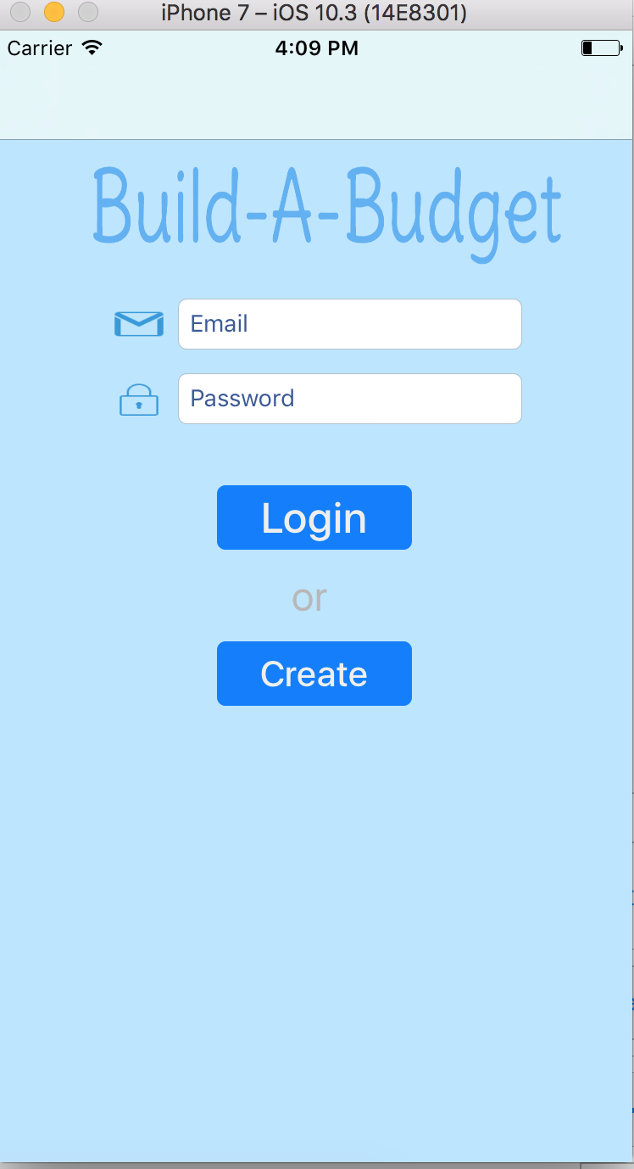

This screen is where the user can login or create an account. If the user wishes to login to his current account, he must enter both his email address (which serves as his username) and his password. The user can also create a new account to use the app. Clicking on the 'Create' button will take the user to the create account screen.

Settings Screen

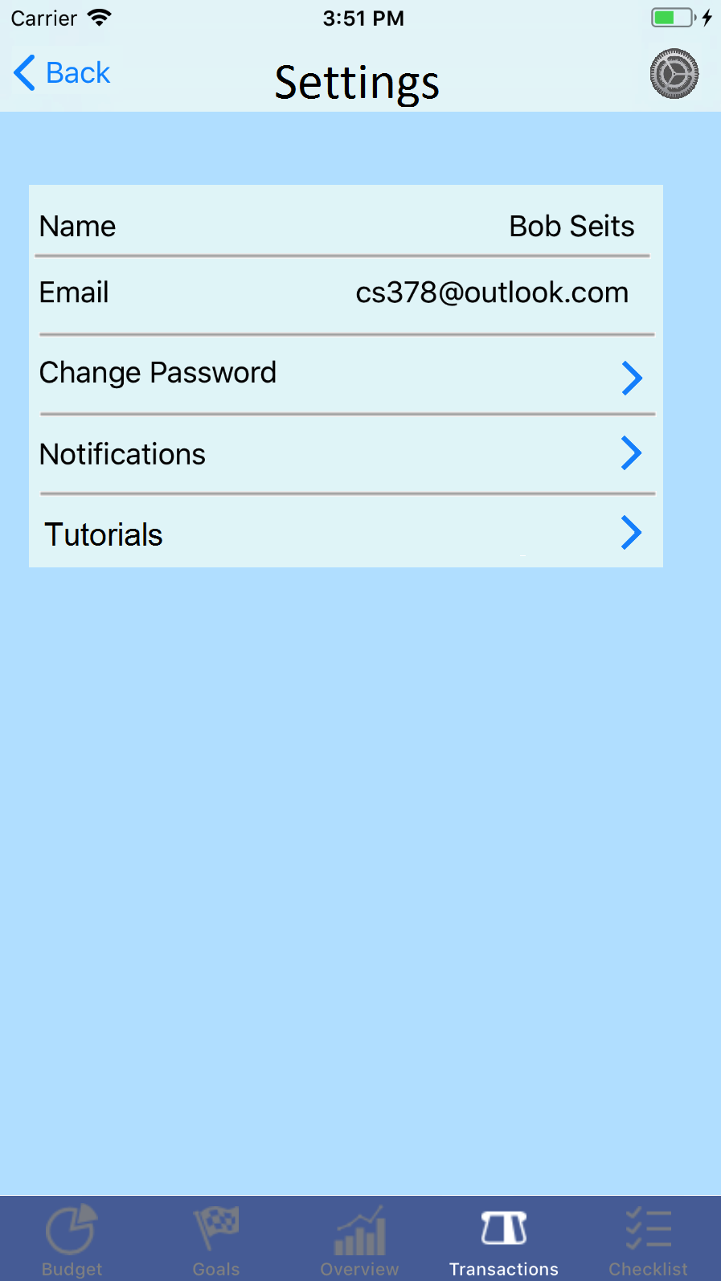

A screen in which the user changes settings. The things that can be changed are name, login email, password and notifications. Additionally, the user can sign out and access the Tutorial slides. The settings screen can be access by clicking the Settings icon appears on in the top left corner of all view controllers except the tutorials screen.

Create Account Screen

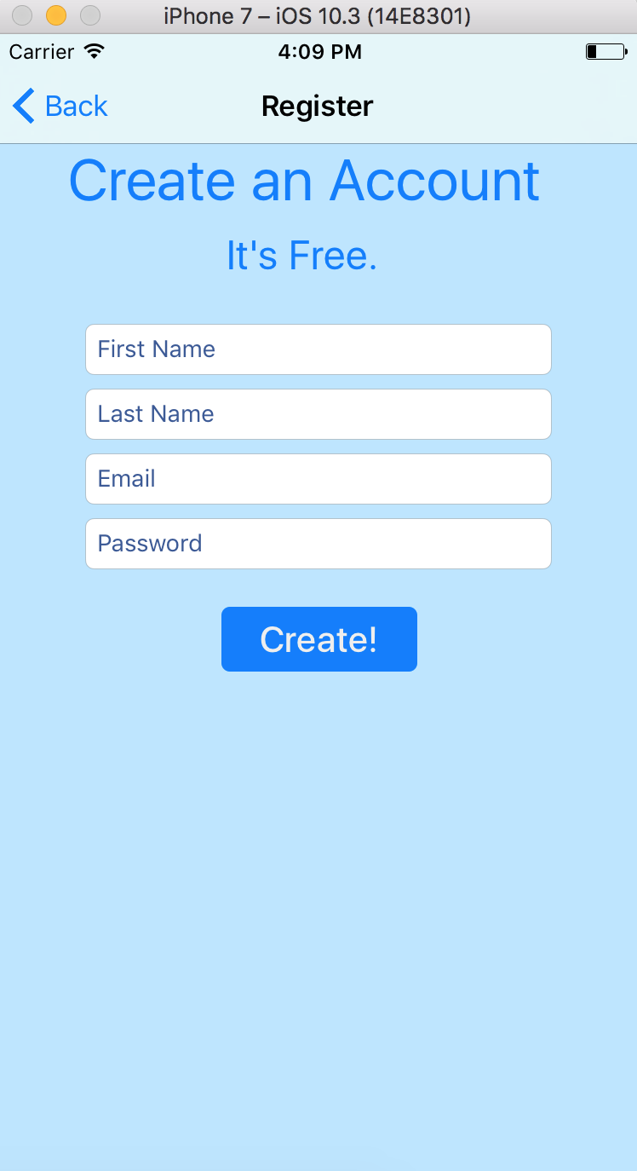  
  
This is where a new user can create a new account so he can start using the app. The user must provide both his first and last name. His email address will be used as his username to login in. Of course, a password is required as well. The 'Create!' button will create the account, assuming that an account with that email address hasn't already been taken.

Launch Screen:

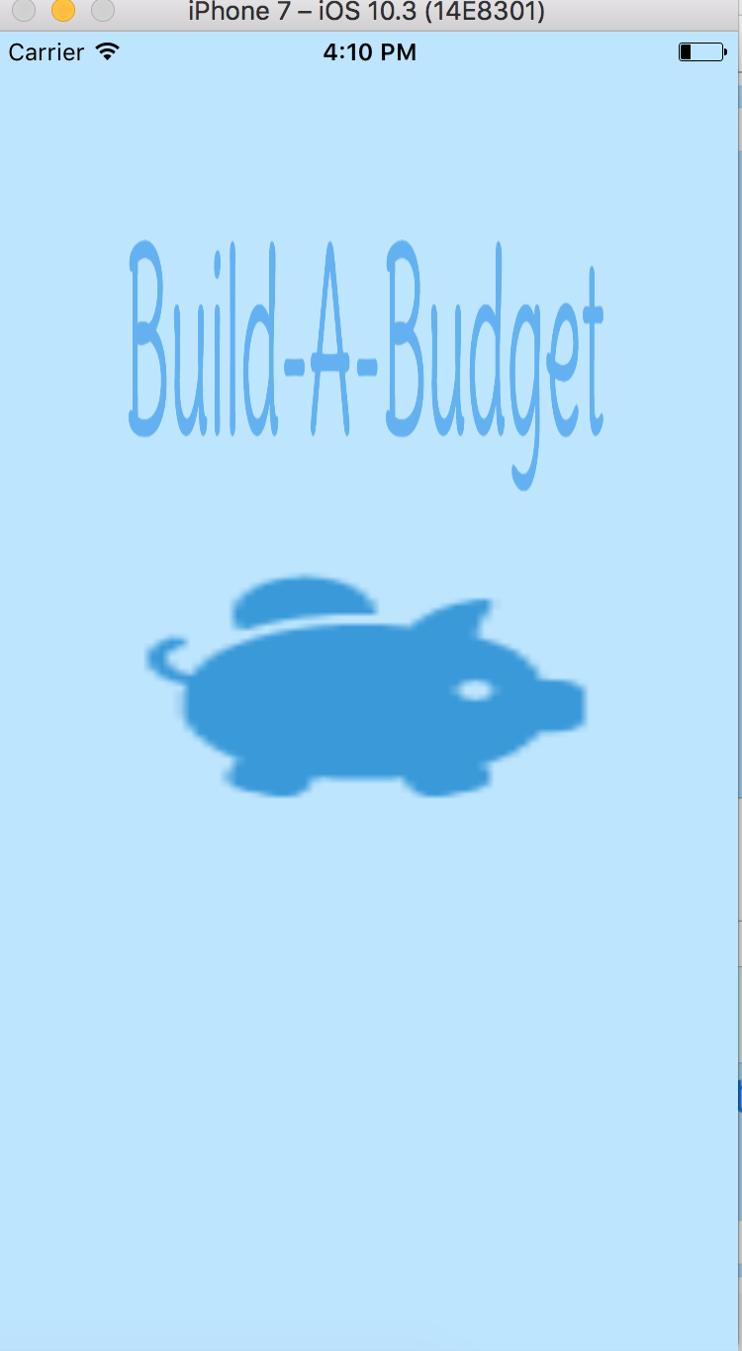

The launch screen is where the user will first see when the user first launches the app. There is nothing for the user to do besides to wait for the app to take him to the logins screen.

Over View:

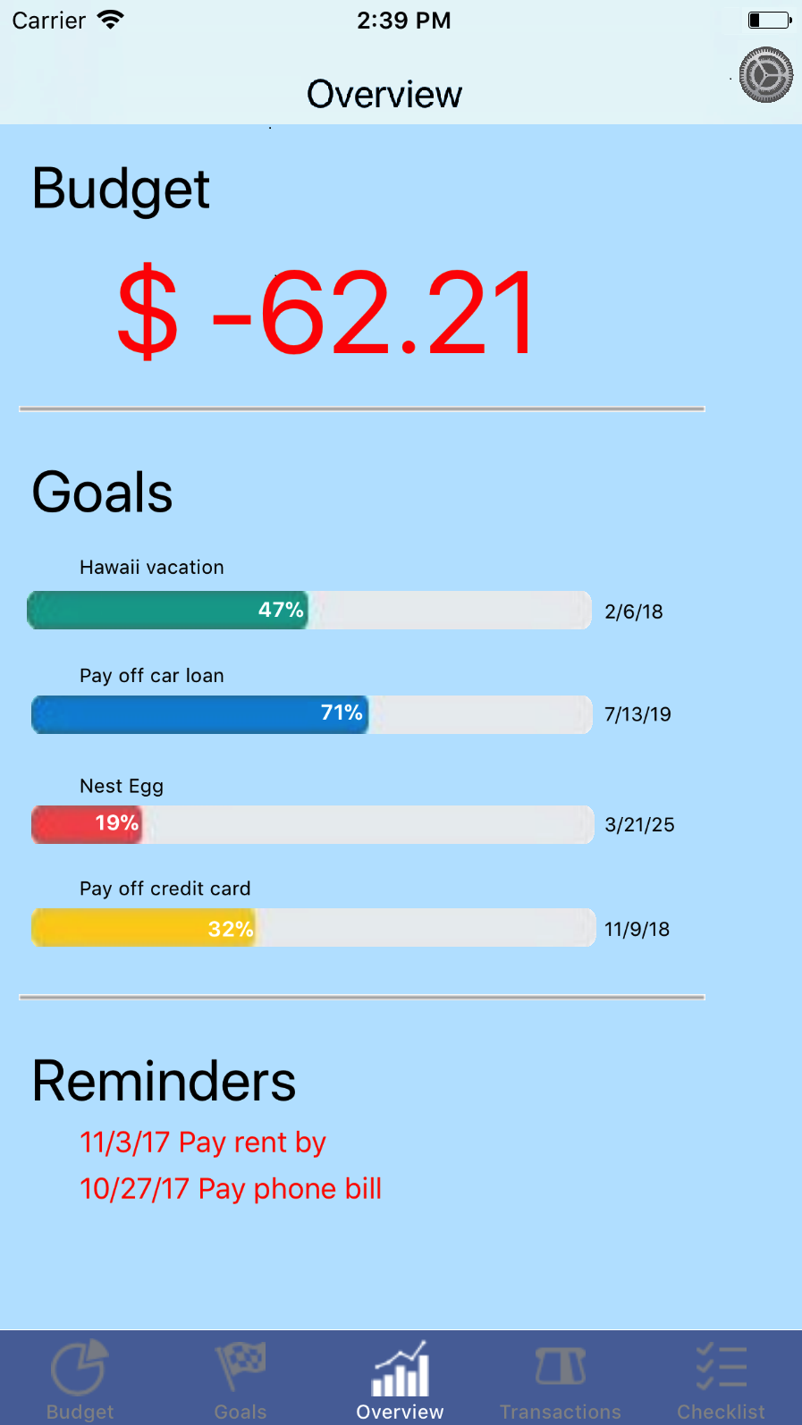

The overview screen is the default screen that the user lands on after logging in. The overview tab view controller functions as an aggregation of status highlights of the most important information contained in the app. The user will first see the prominent heading Budget which provides their current financial status in relation to their budget. The figure will be either a negative red number or a positive black number. The red color serves to reinforce that this is a negative amount so that it cannot be misinterpreted during a glance.

Goals:

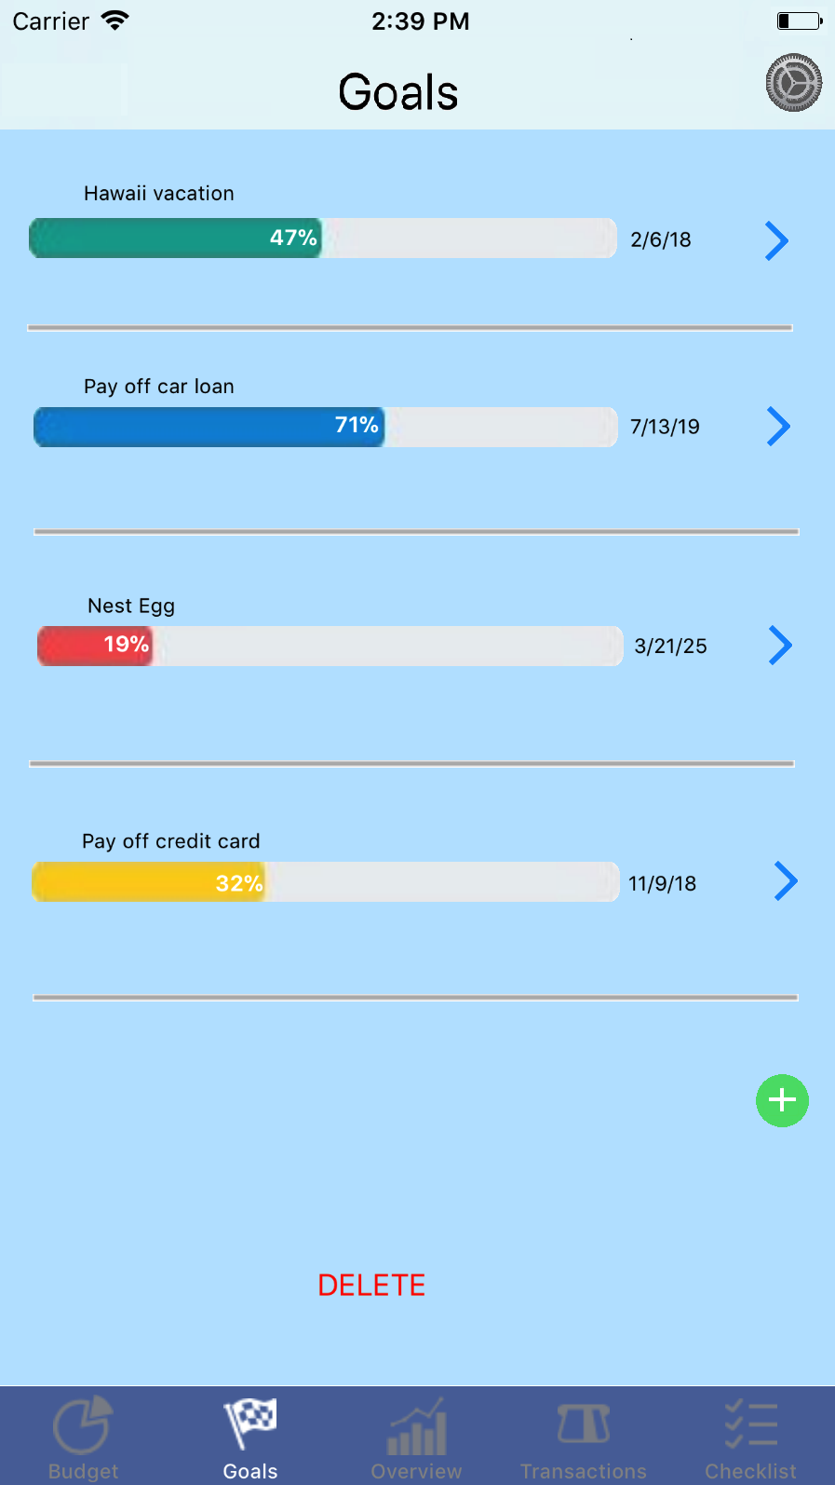

The Goals tab view controller seeks to list all the user’s active financial goals in a list ordered by creation date to make goals easier to search, since it is assumed that user remembers roughly if a certain goal is older than another one. Furthermore, the assumption that older goals will be have had more time to mature will mean that typically the user will see more goals that are closer to completion as soon as they open this tab thereby creating a positive visual reinforcement that encourages users to keep pursing their goals because the first few goals they see will likely be closer to completion.

Configure Goal:

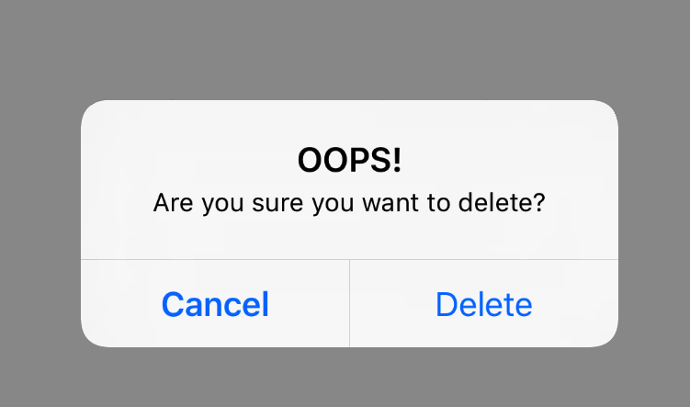

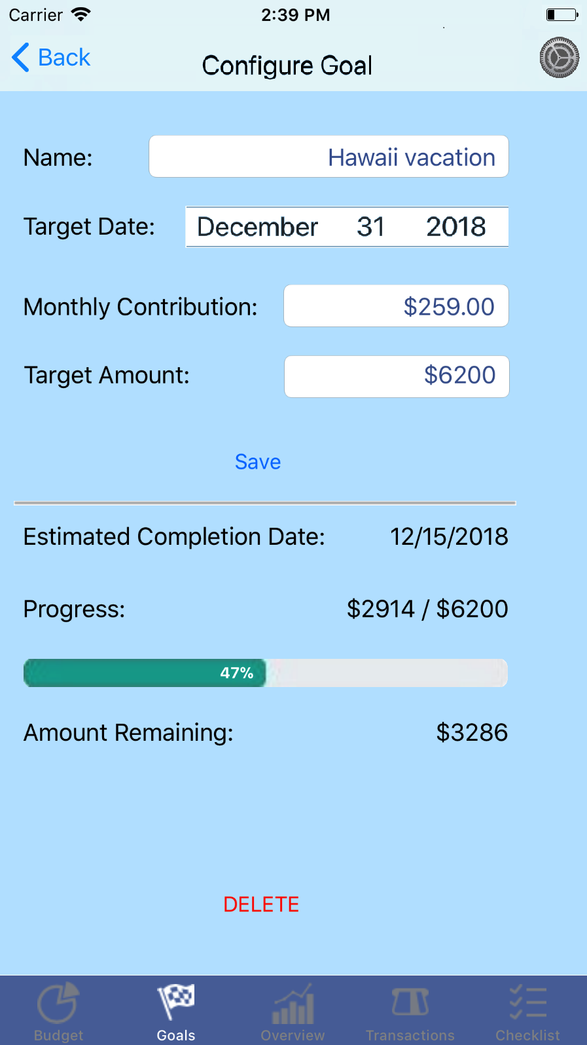

The Configure Goal view controller is only accessible by clicking on the edit arrow adjacent to the Goal in the Goals view controller that the user wants to edit. This is done to avoid unintended clicks and to maintain an easy to remember work flow for the user. This view controller provides two sections that are visually separated by a bar to distinguish the editable information from the un-editable data that this goal has already generated. Clicking DELETE prompts the user with a pop-up alert to confirm that they want to delete this goal.

Monthly Budget:

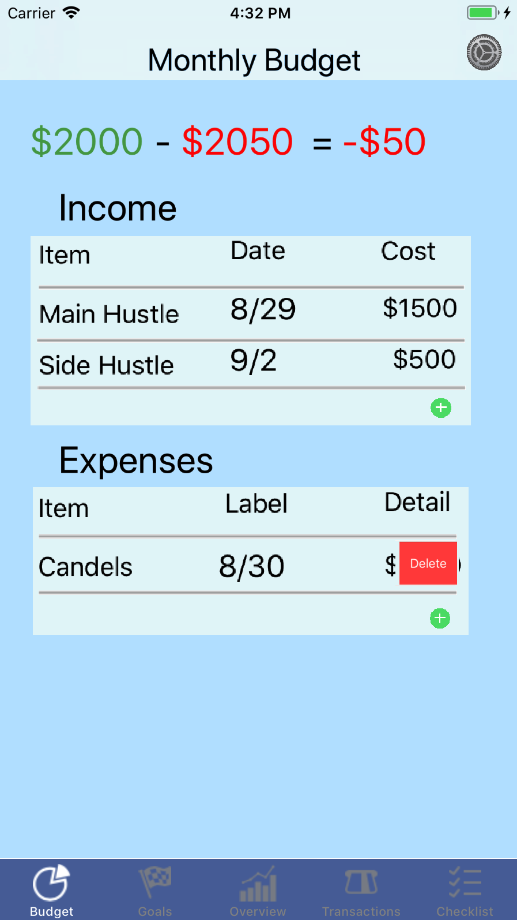

Monthly Income and Expenses: A screen in which the user can view, add and remove individual sources of income and expense. This screen is useful for the user to keep track of how much they are spending and what they are spending money on. If the user wants to add an income or expense they can click on the green add icon located in the next unfilled cell. The user can swipe from right to left on any cell to delete that item. The calculated budget at the top of the screen will recalculate as the user adds and deletes cells on this screen.

Reminders:

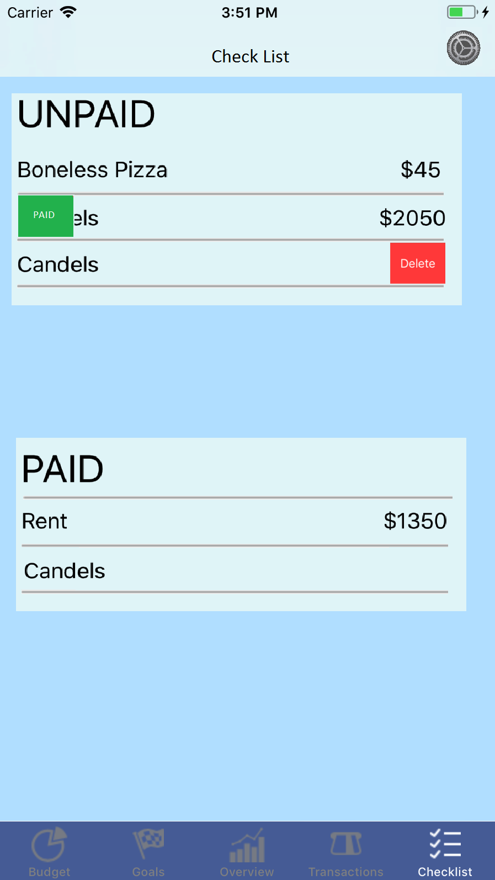

A screen in which the user can view, add and remove reminders for monthly bills/recurring expenses that need to be paid. These are separated by whether they have been paid for the month yet or not. Swiping from the right to the left on any UNPAID cell reveals the delete button which allows them to remove an unpaid bill. Swiping from left to right on any UNPAID cell will allow you to confirm that this bill has been paid. The PAID section shows which bills have been paid this month.

Transactions:

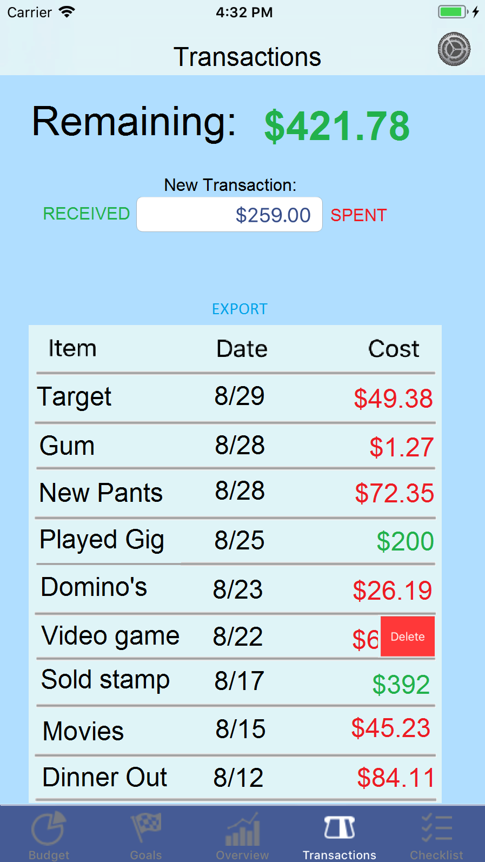

The transactions screen allows the user to record new one-time transactions by entering either an amount and then selecting the RECEIVED button if they were paid, or the SPENT button if they paid. The user can swipe right to left on any cell to delete a transaction. The screen will keep a running total on the amount of money left in the budget that was not already allocated to monthly bills. The user can scroll through the last month of transactions Lastly, the Export button allows users to send the itemized list of all their transactions this month to their email address.

Tutorials

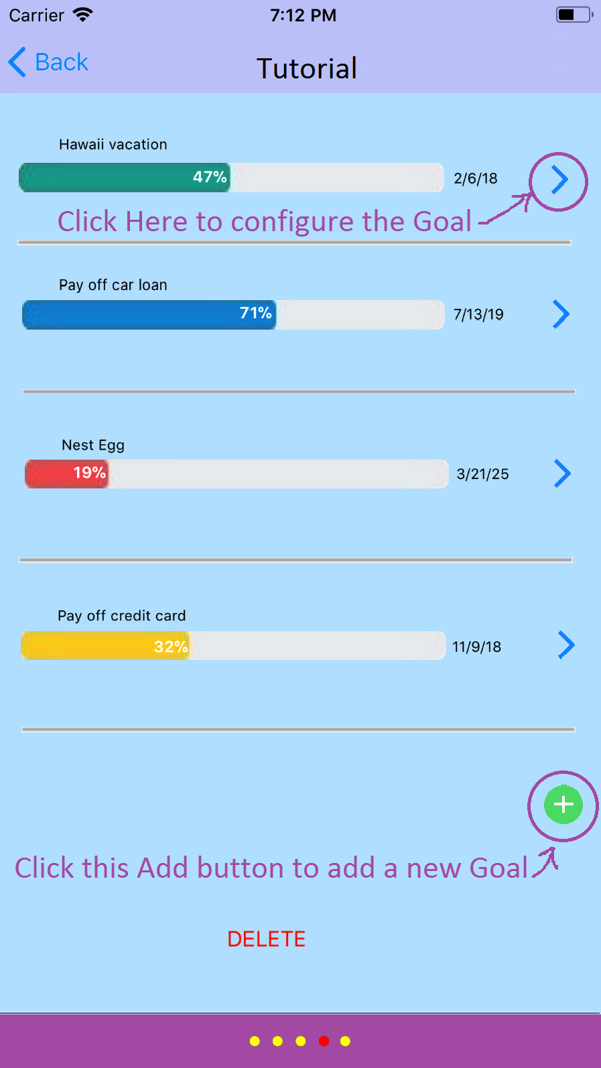

The tutorial screen is access in the setting menu and provides purple text to on each slide that points a screen element and explains its function. The elements on the screen are not interactive but the user will be able to navigate the tutorial by swiping left or right through the different tutorial screens. Clicking the back button returns the user to the Settings view controller.

App Flow Chart

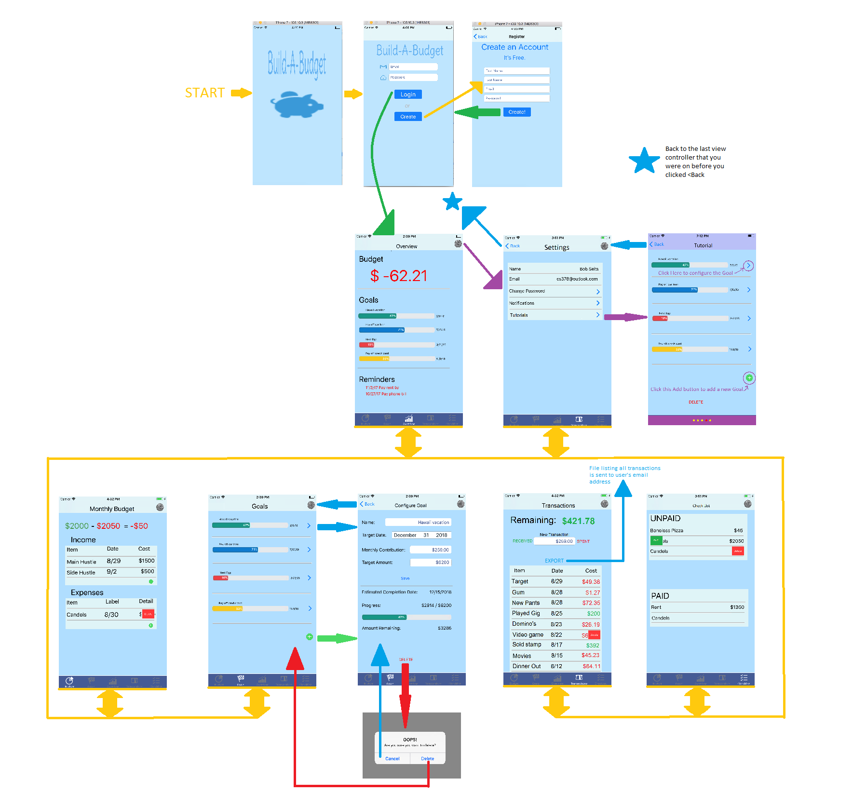

**Operational Descriptions:**

Login Screen

This screen is where the user can login or create an account. If the user wishes to login to his current account, he must enter both his email address (which serves as his username) and his password. The user can also create a new account to use the app. Clicking on the 'Create' button will take the user to the create account screen.

Settings Screen

A screen in which the user changes settings. The things that can be changed are name, login email, password and notifications. Additionally, the user can sign out and access the Tutorial slides. The settings screen can be access by clicking the Settings icon appears on in the top left corner of all view controllers except the tutorials screen.

Create Account Screen

This is where a new user can create a new account so he can start using the app. The user must provide both his first and last name. His email address will be used as his username to login in. Of course, a password is required as well. The 'Create!' button will create the account, assuming that an account with that email address hasn't already been taken.

Launch Screen:

The launch screen is where the user will first see when the user first launches the app. There is nothing for the user to do besides to wait for the app to take him to the logins screen.

Over View:

The overview screen is the default screen that the user lands on after logging in. The overview tab view controller functions as an aggregation of status highlights of the most important information contained in the app. The user will first see the prominent heading Budget which provides their current financial status in relation to their budget. The figure will be either a negative red number or a positive black number. The red color serves to reinforce that this is a negative amount so that it cannot be misinterpreted during a glance.

Goals:

The Goals tab view controller seeks to list all the user’s active financial goals in a list ordered by creation date to make goals easier to search, since it is assumed that user remembers roughly if a certain goal is older than another one. Furthermore, the assumption that older goals will be have had more time to mature will mean that typically the user will see more goals that are closer to completion as soon as they open this tab thereby creating a positive visual reinforcement that encourages users to keep pursing their goals because the first few goals they see will likely be closer to completion.

Configure Goal:

The Configure Goal view controller is only accessible by clicking on the edit arrow adjacent to the Goal in the Goals view controller that the user wants to edit. This is done to avoid unintended clicks and to maintain an easy to remember work flow for the user. This view controller provides two sections that are visually separated by a bar to distinguish the editable information from the un-editable data that this goal has already generated. Clicking DELETE prompts the user with a pop-up alert to confirm that they want to delete this goal.

Monthly Budget:

Monthly Income and Expenses: A screen in which the user can view, add and remove individual sources of income and expense. This screen is useful for the user to keep track of how much they are spending and what they are spending money on. If the user wants to add an income or expense they can click on the green add icon located in the next unfilled cell. The user can swipe from right to left on any cell to delete that item. The calculated budget at the top of the screen will recalculate as the user adds and deletes cells on this screen.

Reminders:

A screen in which the user can view, add and remove reminders for monthly bills/recurring expenses that need to be paid. These are separated by whether they have been paid for the month yet or not. Swiping from the right to the left on any UNPAID cell reveals the delete button which allows them to remove an unpaid bill. Swiping from left to right on any UNPAID cell will allow you to confirm that this bill has been paid. The PAID section shows which bills have been paid this month.

Transactions:

The transactions screen allows the user to record new one-time transactions by entering either an amount and then selecting the RECEIVED button if they were paid, or the SPENT button if they paid. The user can swipe right to left on any cell to delete a transaction. The screen will keep a running total on the amount of money left in the budget that was not already allocated to monthly bills. The user can scroll through the last month of transactions Lastly, the Export button allows users to send the itemized list of all their transactions this month to their email address.

Tutorials

The tutorial screen is access in the setting menu and provides purple text to on each slide that points a screen element and explains its function. The elements on the screen are not interactive but the user will be able to navigate the tutorial by swiping left or right through the different tutorial screens. Clicking the back button returns the user to the Settings view controller.